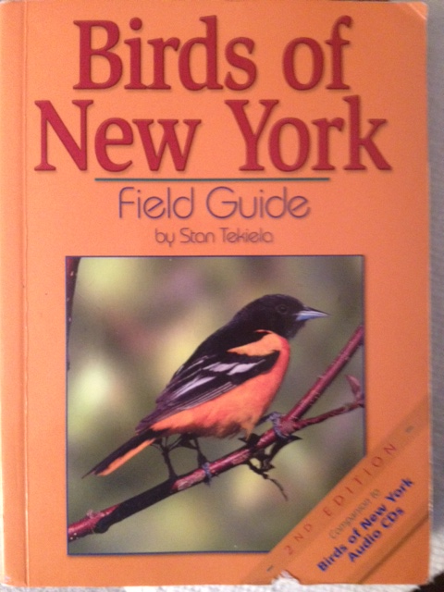AUGUST BIRD OF THE MONTH: 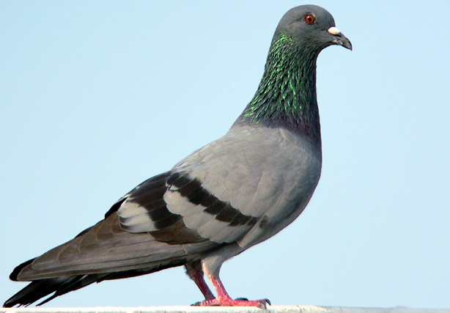
p. 217 PIGEON

I know, I know, “Katie, we have already had the pigeon as a bird of the month!”. I hear you all loud and clear but, there is so much more to discover by watching our neighborhood pigeon flocks!

LISTEN FOR: Deep “Coo’s” as the pigeon sings or a prolonged “Cooooo” as pigeons try to court one another.

REMEMBER YOUR MORPH/BEHAVIOR CHARTS! These pigeon guides are already in your journals. Use them to check off each and every pigeon morph you find!

DISPLAYS: In addition to the pigeon guides you already have check out the behavior guide in this folder! It will help you understand what and why the pigeon is doing during his awesome displays.

Here is a chart to help you keep track of when and what behaviors you saw the pigeon display in the wild! You can use the same chart for any and every other bird you find!
Remember it’s all about your observations!

SPECIES:__________________________
LOCATION:________________________
DATE OBSERVED:____________________
PIGEON MORPH (COLOR): | BEHAVIORS NOTICED | HOW MANY TIMES DID YOU SEE THE BEHAVIOR? | OTHER OBSERVATIONS

