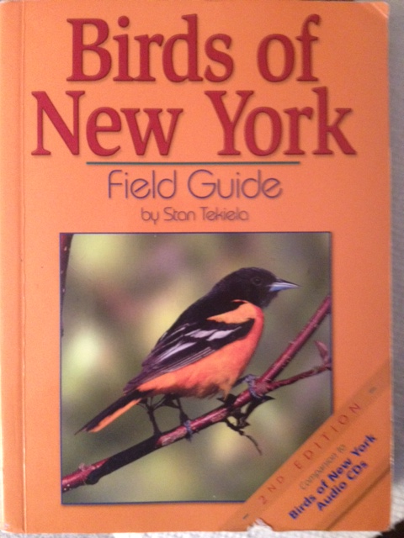 JUNE BIRD OF THE MONTH: 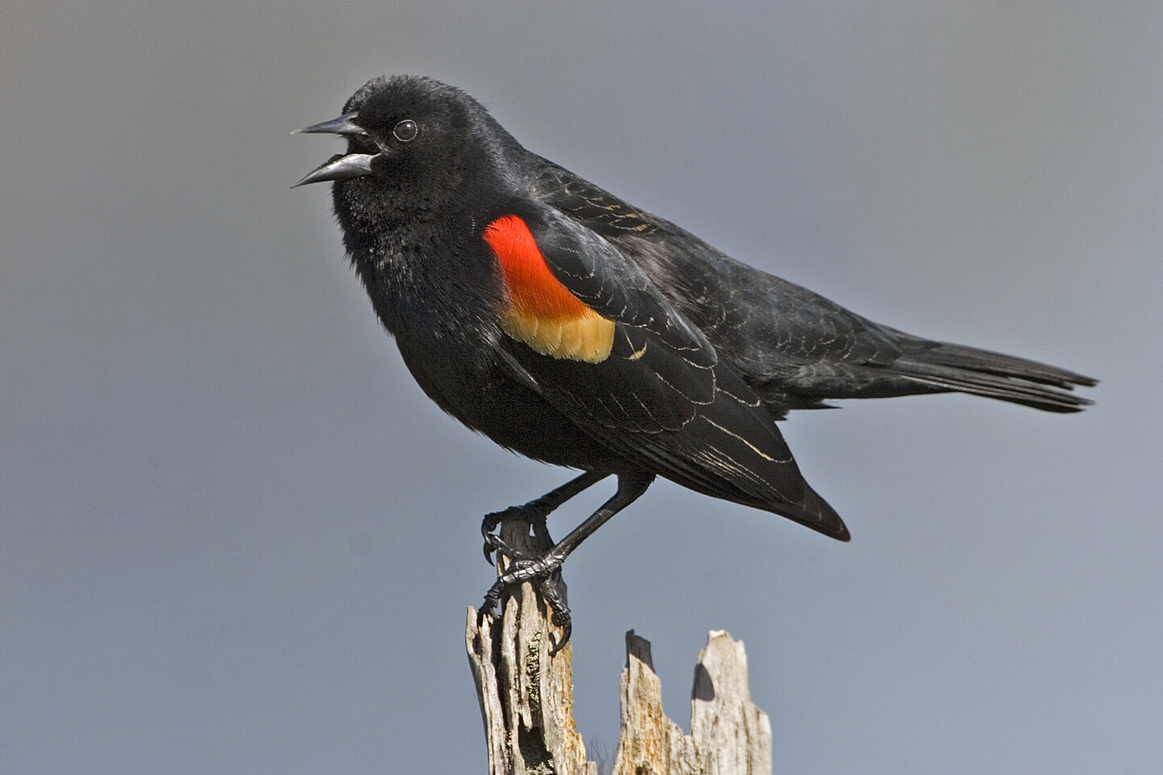
p. 9, 125 Red-winged Blackbird

Red-winged Blackbirds are a wonderful bird to help you practice your observational skills! They are easy to hear, find, and a pleasure to watch in the wild.

LISTEN FOR: Deep, raspy, “Coo-Coo-Curry” sounds. The call of the Red-winged Blackbird is abundant especially in marshes. They can be heard and seen all over NYC!

DISPLAYS: Check out the Red-winged Blackbird behavior worksheet in this folder – it will help you understand what and why the Red-winged Blackbird is doing during his awesome displays.

Here is a chart to help you keep track of when and what behaviors you saw the Red-winged Blackbird display in the wild! You can use the same chart for any and every other bird you find!
Remember it’s all about your observations!

SPECIES:__________________________
LOCATION:________________________
DATE OBSERVED:____________________
BEHAVIORS NOTICED | HOW MANY TIMES DID YOU SEE IT? | OTHER OBSERVATIONS

