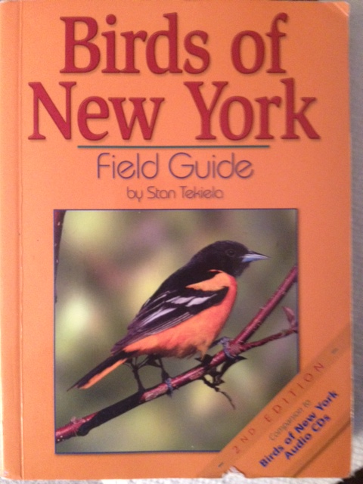 JULY BIRD OF THE MONTH: 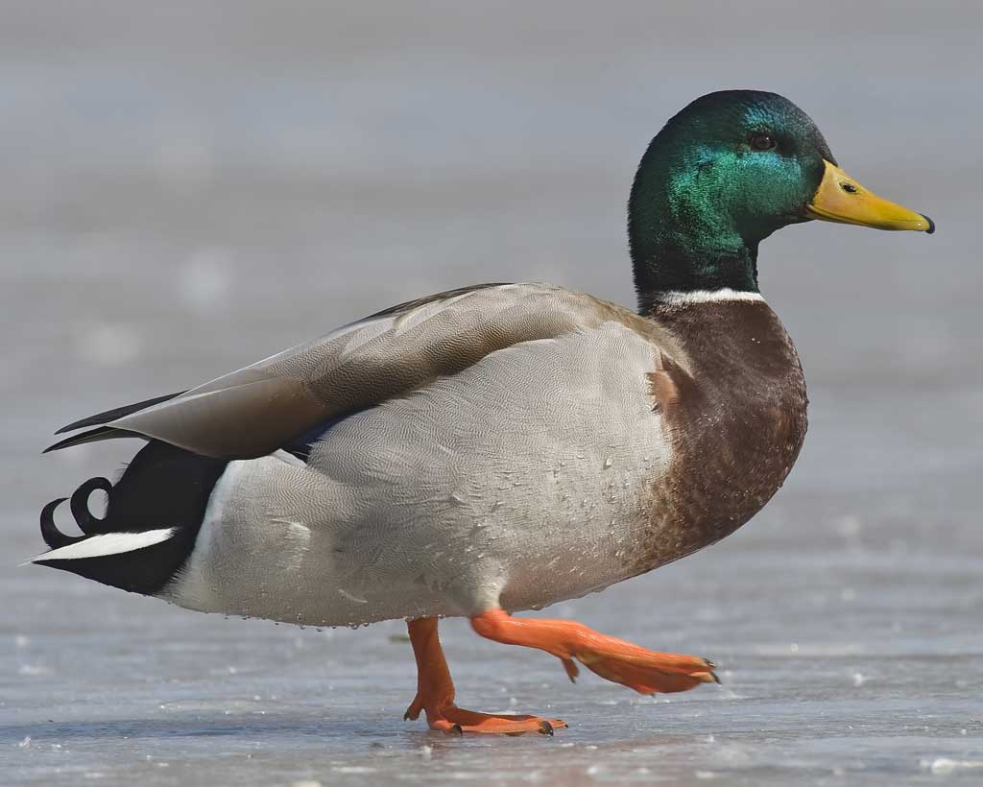
p. 171, 239 MALLARD

Mallards are one incredible dabbling duck! The males are easy to recognize by their large green heads!

LISTEN FOR: The stereotypical QUACKING noise of a duck, QUACK, QUACK, QUACK – this is the female mallard calling. The male Mallard does NOT quack – he makes a raspy, short call instead.

REMEMBER ADAPTATIONS! Well, you can check out the Beak sheet in this folder to see how Mallards Bills help them eat!

DISPLAYS: Check out the Mallard Courtship behavior worksheet in this folder – it will help you understand what and why the Mallard is doing during his/her awesome displays.

Here is a chart to help you keep track of when and what behaviors you saw the Mallard display in the wild! You can use the same chart for any and every other bird you find!
Remember it’s all about your observations!

SPECIES:__________________________
LOCATION:________________________
DATE OBSERVED:____________________
BEHAVIORS NOTICED | HOW MANY TIMES DID YOU SEE IT? | OTHER OBSERVATIONS

